**1. Rollout**

Create a namespace:

* kubectl get namespaces
* kubectl create namespace misc-namespace
* kubectl create deployment faraz-nginx --image=nginx -n misc-namespace

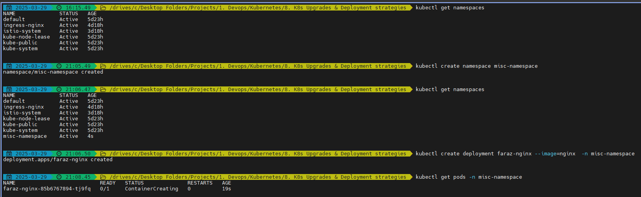

Now edit the deploy:

* export EDITOR=notepad
* kubectl edit deploy faraz-nginx -n misc-namespace

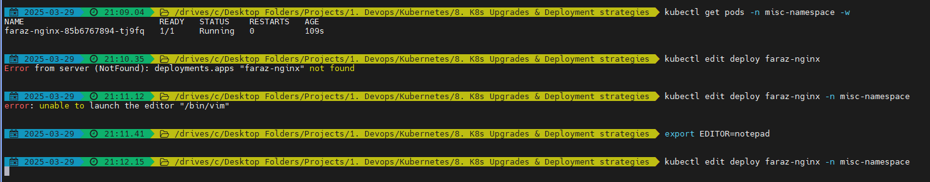

Edit the number of replicas from 1 to 4

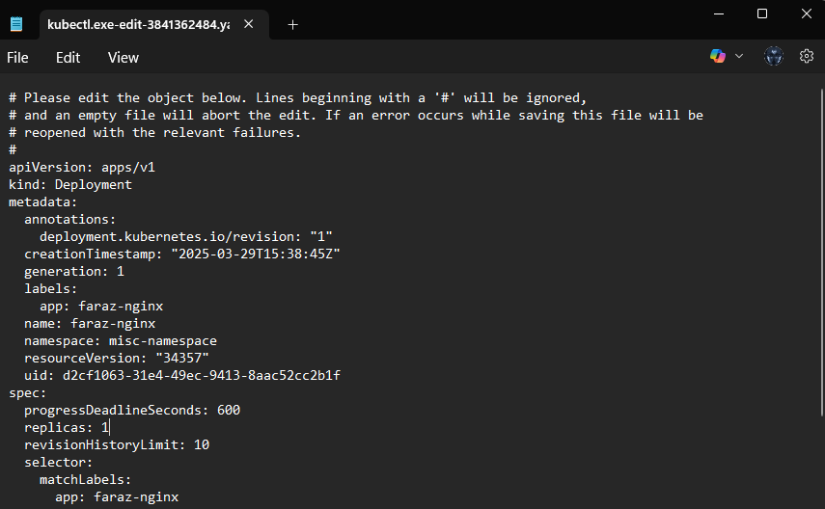

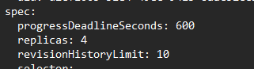



Now let’s simulate the worst case where the image doesn’t exist:

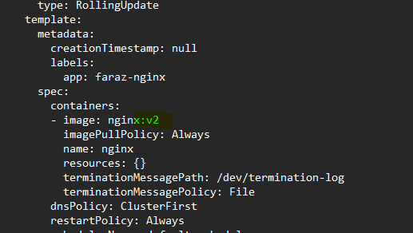

It will target 1(25%) replica & create try to perform rolling update by trying to create 1 newer version replica. Now since we don’t have readiness probe configured, the older version got terminated and newer version replaces the older version

We will enter into ImagePullBackOff loop:

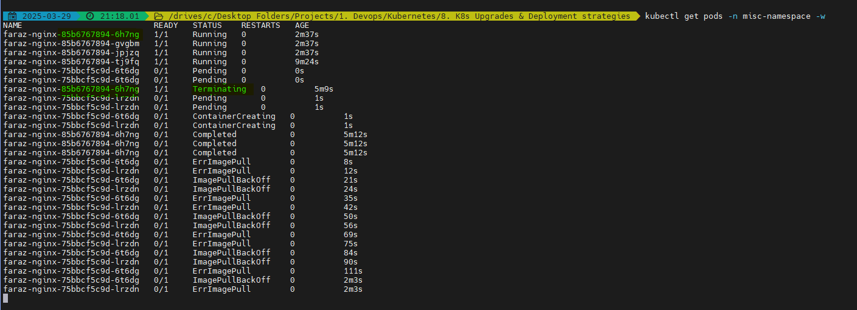

Here we can see that we have 3 healthy pods and service will now forward the request to healthy pods:

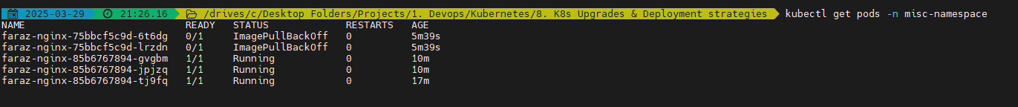

* Hence, using rolling updates, since traffic flows to the healthy pods, end user may not see downtime.
* If everything goes smoothly, one by one all the pods will be upgraded to v2

You can then delete your deployment: kubectl delete deploy faraz-nginx -n misc-namespace



**1. Canary:**

You can list down the addons on minikube:

* minikube addons list
* minikube addons enable ingress

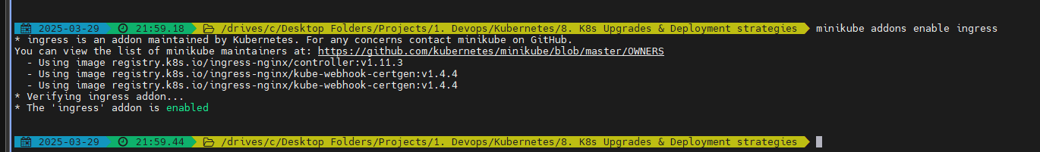

Make sure your ingress-nginx controller is running:



We can follow the steps mentioned in: <https://kubernetes.github.io/ingress-nginx/examples/canary/>

Create deployment and service for **version 1**:

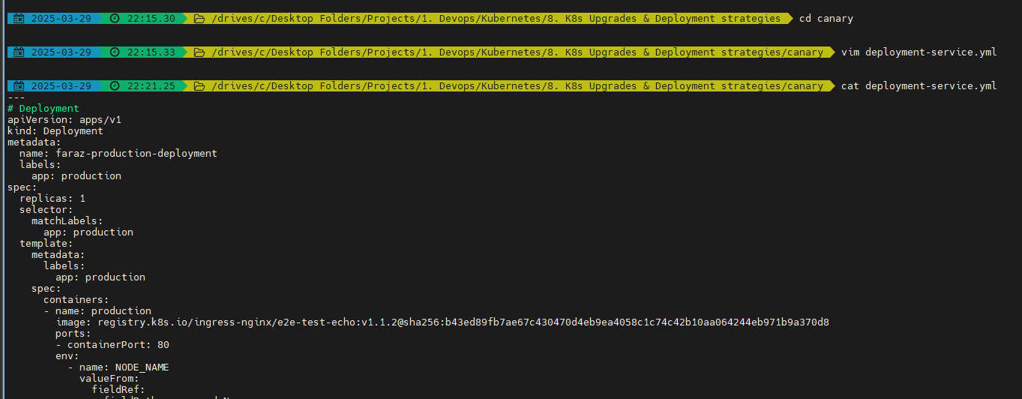

Similarly, create deployment and service for **version 2**:

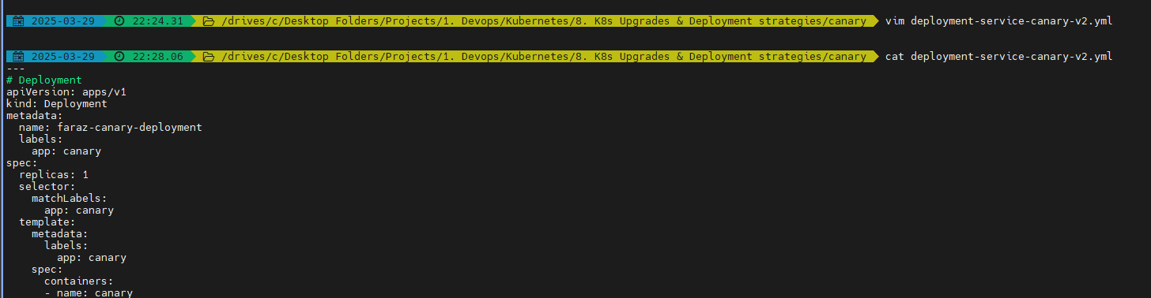

Now create Ingress:

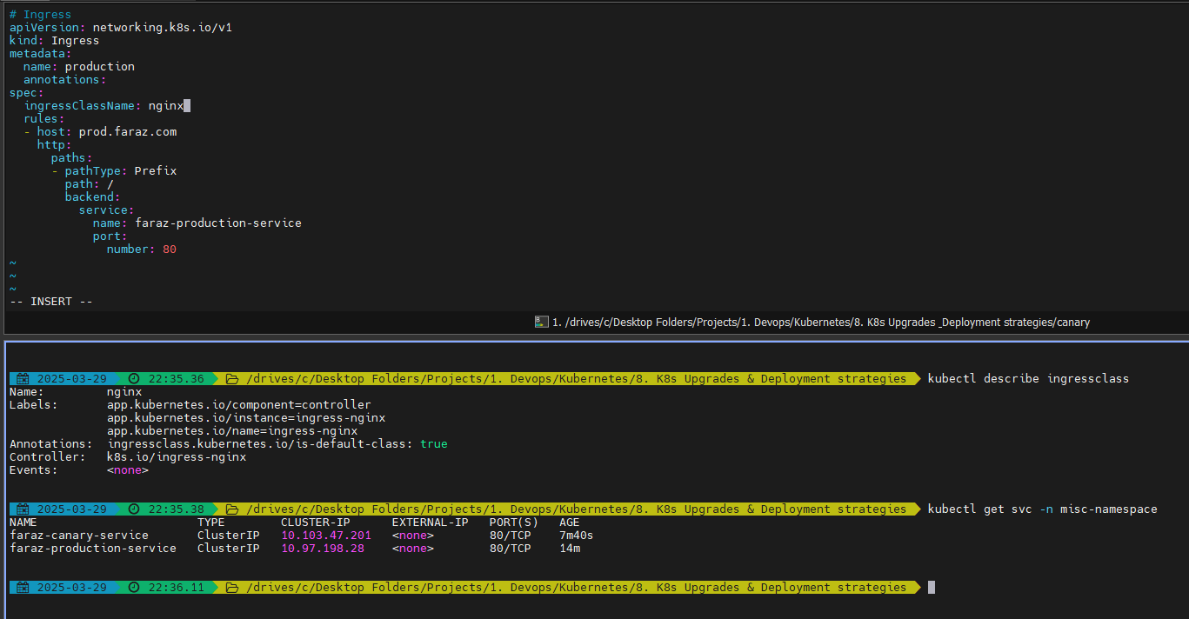

Similarly, create ingress for canary:

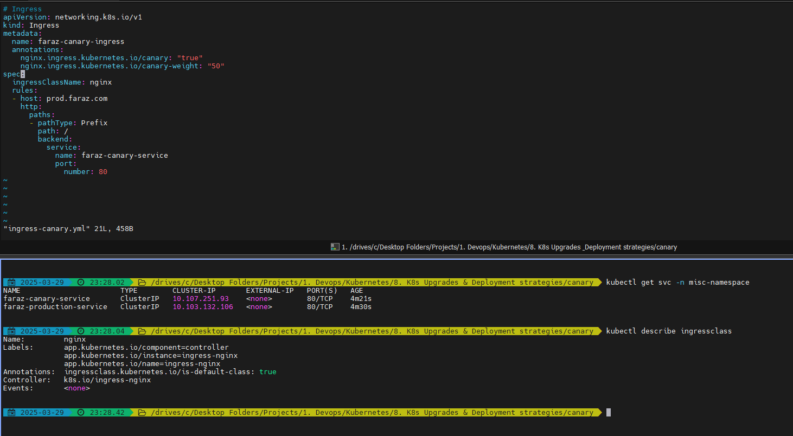

Ensure your deployment, service, ingress are up and running:

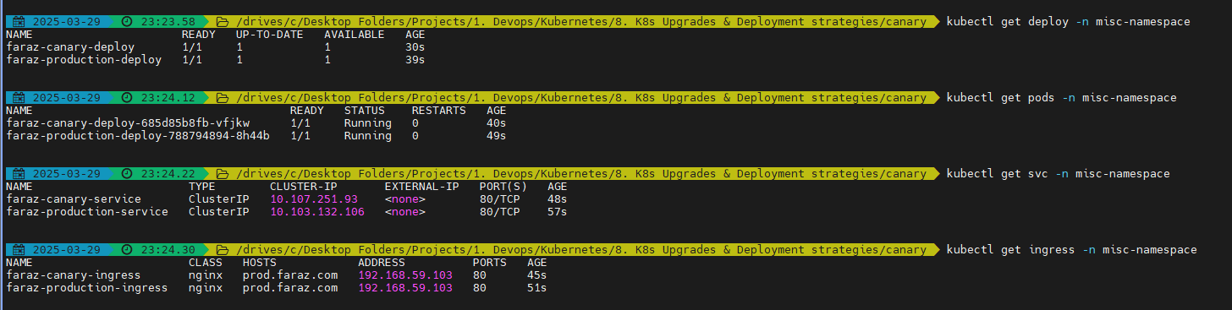

Now since the ingress canary is setup to 50% the traffic will be distributed evenly:

* for i in $(seq 1 10); do curl -s --resolve prod.faraz.com:80:192.168.59.103 prod.faraz.com | grep "Hostname"; done

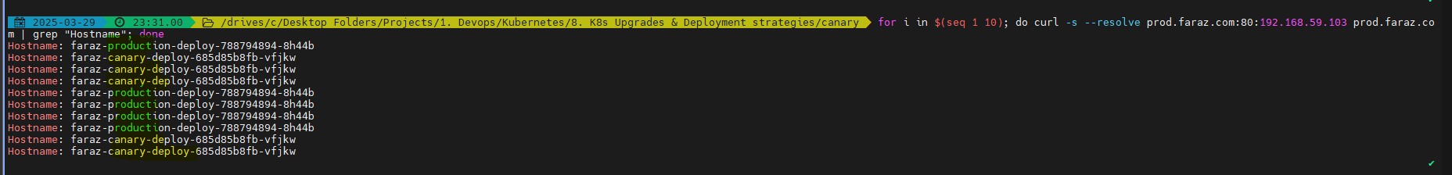

Now if we want to forward 10% of the traffic:





